CATHOLIC BISHOPS CONFERENCE
of
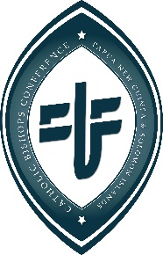
Papua New Guinea and the Solomon Islands
Office of the President
P.O. Box 398
Waigani, NCD
Papua New Guinea
Ph: (675) 325 9577
Fax: (675) 323 2551
Email: cbcgensec@catholic.org.pg

16 March 2019

His Excellency Bishop Paul Martin, SM
Christchurch, New Zealand

Dear Bishop Paul;

Greetings of Peace from Port Moresby, Papua New Guinea!

It is with great sadness that the Catholic Church and the people of Papua New Guinea and the Solomon Islands learned of the tragedy in Christchurch. It bothers us to see the kindness and hospitality of New Zealand hit by bad feelings and ideologically unacceptable views.

It is heartbreaking that people are attacked based on traditions, culture and religion; and especially as this happens at a time when the countries of the Pacific are called to greater openness, understanding and cooperation to face the global migration crisis.

We are planning a day of prayer for Peace and Dialogue across Papua New Guinea and Solomon Islands during this Lenten season.

May the Father of all give Peace to those who have lost their lives, and console the families and the communities so deeply grieving.

In Christ:

+ Rochus Josef Tatamai, MSC - Bishops of Kavieng
President, Catholic Bishops Conference of Papua New Guinea and Solomon Islands

